**SCENE**

Load scene "**MainScene**".

Go to GameManger(GameObject) -> GameManager(script)

In "Level" field set level as 21(Initial levels and levels which are multiples of 5 are short,so select level 21)

Check "Set Level" checkbox(This directly plays level 21)

All levels are randomly generated. So playing level 21 multiple times gives you different "Levels".

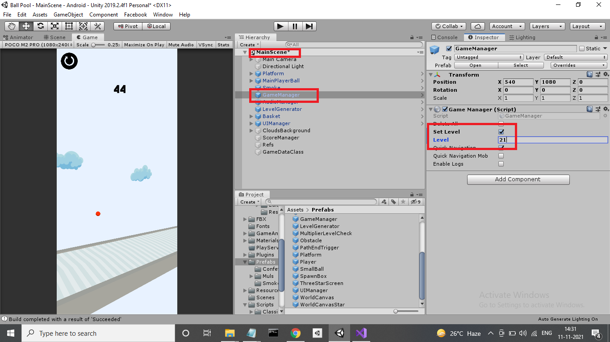

**HOW TO PLAY**

Press **Space Bar** key for controlling the ball. Flappy bird mechanic. Tap, tap…

**OBJECTIVES**

Pass through numbered gates and multiplier gates to generate balls.

TYPES OF GATES

Each level is randomly generated with these gates in random order and random number values.

